**BCVD1006 – Full Stack Development – Lab 9**

* JavaScript Loops

**Developer Note:**

* Please create a separate JavaScript file for each exercise
* You may use the HTML page to trigger your scripts or you may use the JS Playground Editors (REPL) to program and just submit the JS file.
  + <https://repl.it/languages/javascript>
  + <https://jsfiddle.net/>

**Exercise 1:**

Create a function named **findOddOrEven** that has the following requirements:

* Takes zero parameters
* Write a for loop that will iterate from 0 to 10.
* For each iteration, it will check if the current number is even or odd, and then output
  + number is even or number is odd

Expected output is as follows:



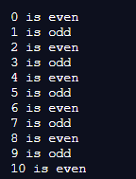

**Exercise 2:**

Create a function named **helloWorlds** that has the following requirements:

* Takes a **number** as parameter
* Will check whether the param is a number or not a number
  + If the param is a number, output “**Hello World**” x num
  + Otherwise, if not a number output “**Goodbye World**”
* Hint: you may need to a for loop for this exercise

Expected output is as follows:  
  
  
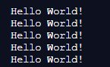  
  
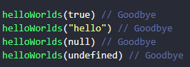

**Exercise 3:**

Create a function named **greaterThanSize** that has the following requirements:

* Takes no parameters
* Calculates a random local variable named size
* Does a while loop that does the following
  + increments a counter by one
  + output the current size and counter
  + continues until the counter is greater than the size
* The output will be different every time, because the size number will be different
* Hint: you may need use Math functions for the random size

Expected output is as follows:  
  
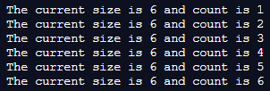  
  
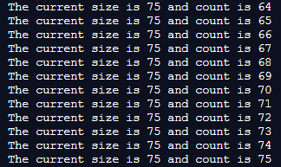

**Exercise 4:**

Create an HTML file that links an external JavaScript file named **Ex4.js**. The script has the following requirements.

* Invokes a function named **startClock** with zero parameters and does the following
* Does a **do while** loop that does the following
  + calculates the **current date time**
  + outputs the current date time in a **nested loop 10 times**
  + prompts the user “Do you want to stop the clock?”
    - **OK**, will continue running the clock
    - **Cancel** will stop and exit the loop and function
* Hint: you may need use Data and Date formats

The user prompt will be as follows:

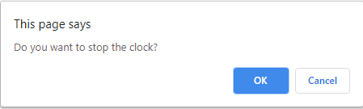

Expected output is as follows:

